Everyone is a gift and everyone is gifted
Headteacher Recruitment Pack

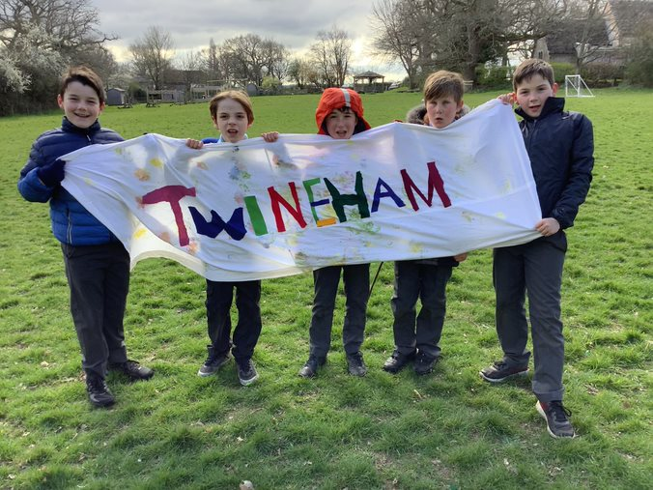
www.twineham.w-sussex.sch.uk
Contents

Letter from the Chair of Governors 3
Our Vision and Values 5
What makes a good head teacher? 7
Twineham - Key Facts 9
Job description 10
Person Specification 12
Ofsted Quotation 15
Twineham, West Sussex - Our locality 16
Twineham CofE School: Information for Applicants 17

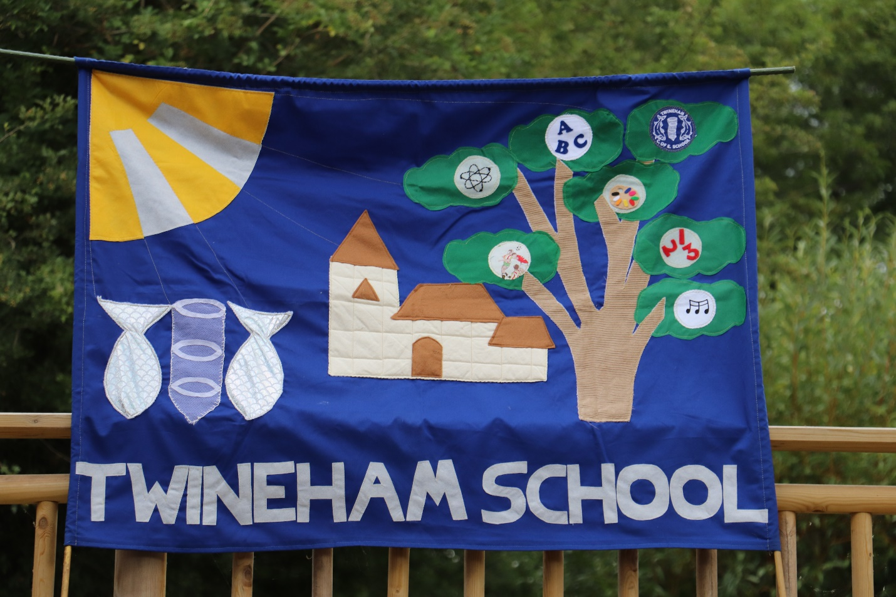

Everyone is a gift and everyone is gifted

Letter from the Chair of Governors

Dear Applicant,

Thank you for your interest and taking the time to consider becoming Head Teacher of our wonderful family school.

Twineham is a very special place and we are looking for the right person, who will be able to take forward our Vision and Values. We are a small rural primary school situated in a quiet location adjacent to the Church, which the children use and enjoy as part of their learning.

Our Christian ethos is a key part of school life and our new Head Teacher will be expected to embrace this in a positive manner, allowing each child the opportunity to “live life in all its fullness” in order, as John Sentamu said, that they can “have life and have it more abundantly.”

We are a maintained Voluntary Controlled primary school, with a PAN of 15, currently accommodated in 4 classes, from Reception to Year 6. Outdoor learning is a much valued part of what we can offer our children at Twineham, reflecting our location, community and values. Our welcoming atmosphere and nurturing, safe environment allow teachers to commit to meeting the needs of all children who are treated with respect and equity. Aspirations are high and we aim to help each child to reach their potential.

Safeguarding is taken very seriously and all applicants will be required to undergo checks to comply with safer recruitment procedures.

Currently we have an internally appointed acting Head, following two terms under an Executive Head. We are now looking to build upon the work done so far and to drive curriculum development, subject leadership and early reading forward, in line with the recommendations in our recent Ofsted report. A committed, dedicated leader is required, to take on these areas for development, ready for our next graded Ofsted inspection potentially in 12- 18 months.

Our enthusiastic, experienced, loyal and hardworking staff are central to promoting our vision, values and ethos, which are lived, seen and heard in school, and a new Head Teacher will be expected to harness their support, to achieve our development plan goals. The Head will also be expected to work with the Governors, the Parish priest, FOTS (Friends of Twineham School, which is the PTA), the wider community, WSCC, the Diocese and external agencies.

If you feel you can make a positive leadership contribution to our small school, to take us on the next stage of our exciting journey, we would very much like to hear from you. The pack aims to give a flavour of our school, but please do come and visit, to see and experience for yourself, what we have to offer.

To arrange a visit, please contact Siobhan Reynolds (Office) or Mary Candy (Bursar) on 01444 881207 or office@twineham.w-sussex.sch.uk by email.

Yours faithfully,

Margaret Smith
Chair of Governors.

March 2023

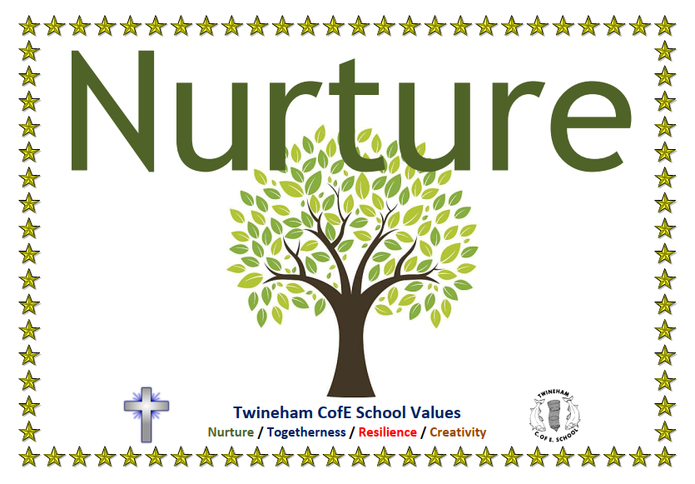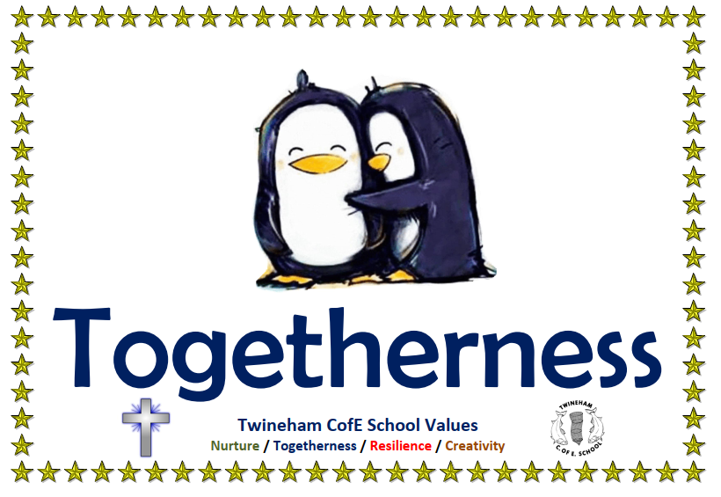

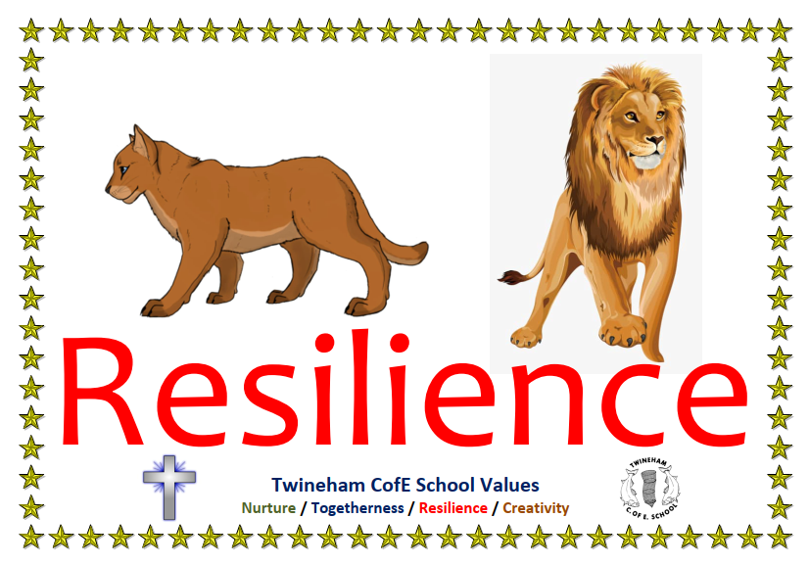

Everyone is a gift and everyone is gifted

Our Vision and Values

“The school’s values of nurture, togetherness, resilience and creativity thread through all aspects of the provision,” and “leaders’ vision ‘that everyone is a gift and everyone is gifted’ is at the heart of everything they do,” Ofsted 17 November 2022.
At Twineham CofE School, we believe that everyone is a gift and everyone is gifted. Every child is special and unique. Our school values are underpinned by our Christian ethos in our words and actions every day.
Our school values help us to promote British values of democracy, the rule of law, individual liberty and mutual respect for those of every faith.
We strive to NURTURE and support every child to grow their talents in a happy and safe environment.
Our school community thrives on TOGETHERNESS, working closely with families to help children through teamwork and mutual support.
We promote growth mindset and perseverance, helping children to build RESILIENCE and CREATIVITY for an inspirational life of learning and growing.
We aim to prepare our children for their next step along the educational journey and to help make them responsible members of the community in the future.

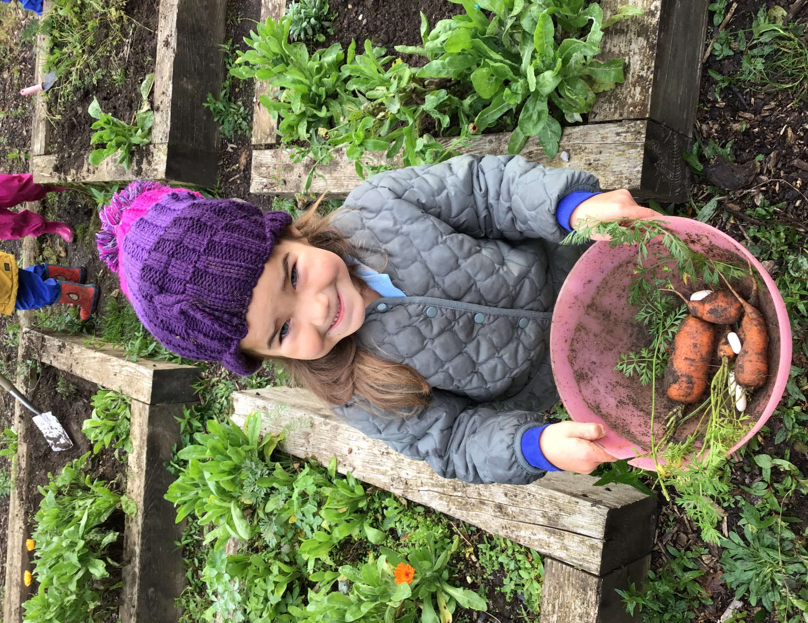

What makes a good head teacher? The Children said….

- They will need to be kind and not that strict.
- Someone who helps us with our learning.
- Someone that will help you.
- Helps to organise stuff for us to go to, like the summer fair.
- Someone who is calm.
- Makes money for the school to buy the things we use.
- Someone who celebrates our good work.
- Someone who is sensible.
- Interacts with children.
- Someone who helps us with lessons.
- Someone who is friendly.
- Someone who helps people when they fall over.
- A creative head teacher.
- Good with electrics! Can fix a whiteboard!!

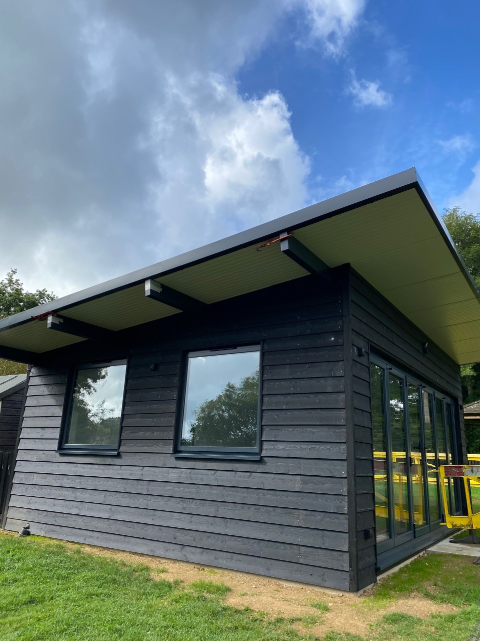
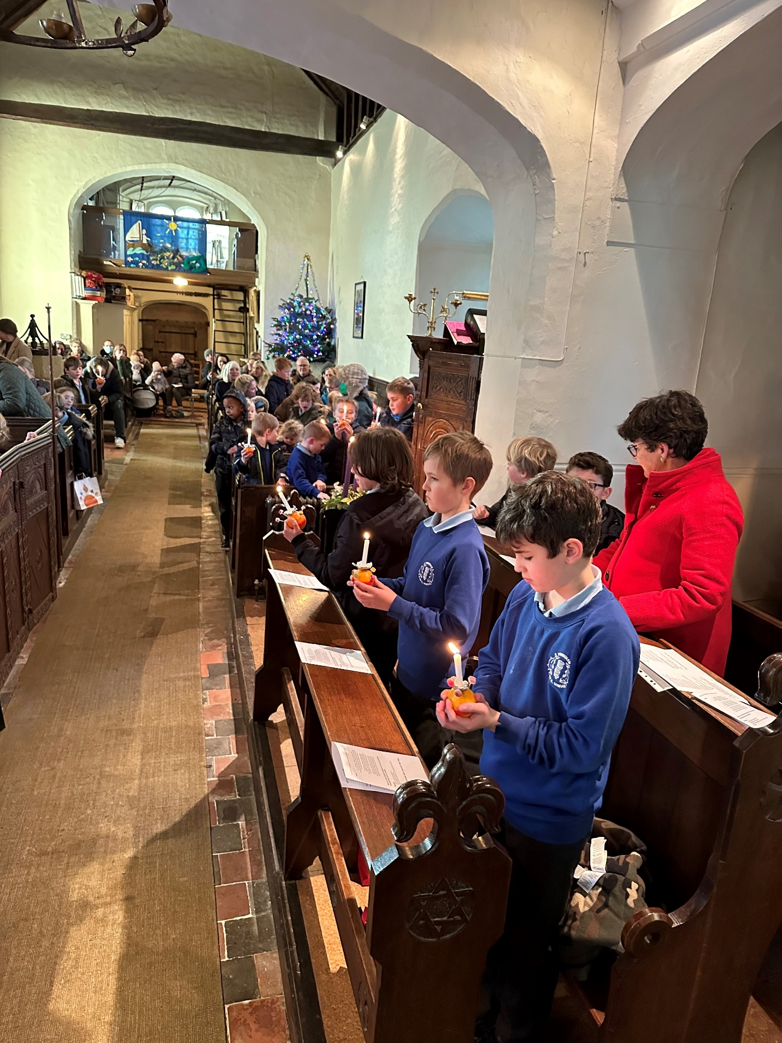
Twineham - Key Facts

Type of School | Church of England Primary School
School Category | Voluntary controlled.
School age range | 4 – 11 years
Arrangement of year groups | A PAN of 15 (Class split: Reception, Years 1 and 2, Years 3 and 4, Years 5 and 6.)
Number on roll | 68 (28% girls, 72% boys)
Location | Twineham, West Sussex
Co – educational or single sex | Co – educational
Number of pupils per teacher | 17
Number of teaching staff | 4 full time equivalent, class teachers
Number of children on FSM | 7
Percentage of children with SEN support | 34%
Number of children with an EHCP | 4
Ofsted grade (ungraded Section.8 inspection) | Good, 17 November 2022
SIAMS | Good, 18 January 2018

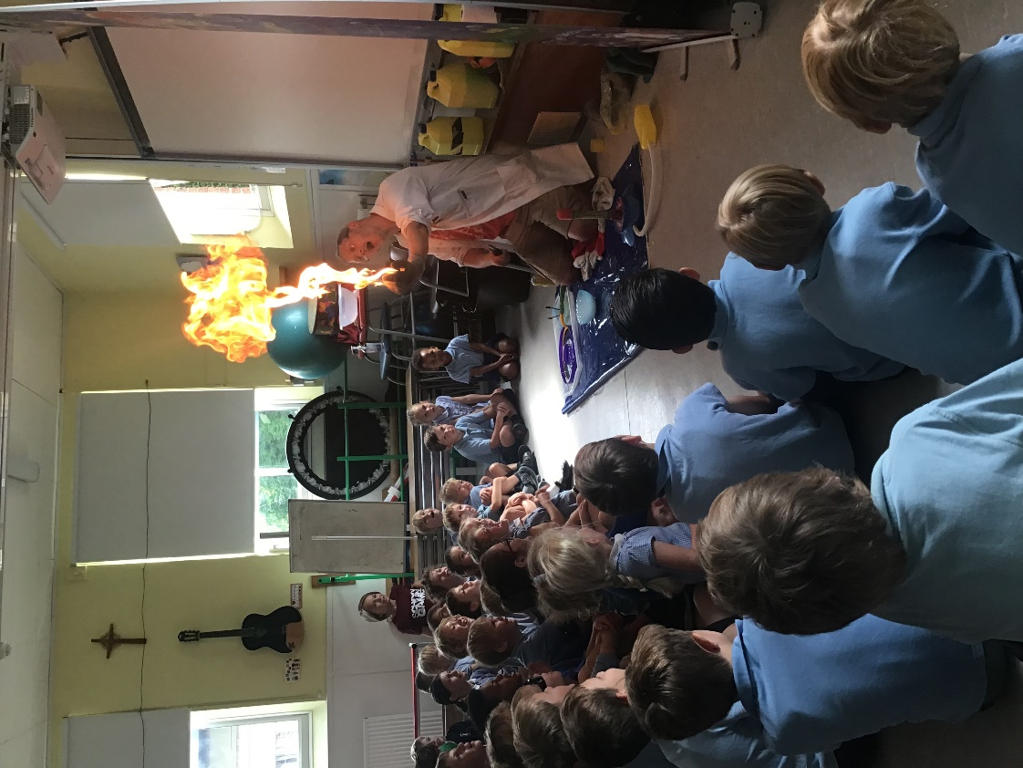

Job description
School name: Twineham Church of England Primary School
Job title: Headteacher
Pay range: Group 1 school, ISR L9 – L15 £51,402 - £59,581
Responsible to: The Board of Governors

Main Purposes of the Job
The headteacher will:
- Provide outstanding professional leadership of the school to deliver continued success in pursuit of excellence and equality in pupil outcomes.
- Embody and promote the school’s Christian ethos, values and culture.
- Ensure all children are valued and enabled to grow and achieve academically, socially and emotionally.
- Work with the governors to create and communicate a shared vision, ethos and strategic plan that inspires and motivates all stakeholders and reflects the need of the school and the wider community.
- Set clear objectives that promote and sustain school improvement and ensure the school develops to benefit pupils, staff and communities.

Qualities and knowledge
The headteacher will:
- Hold and articulate a clear Christian vision for the school, ensuring this vision is clearly shared and acted upon by all.
- Demonstrate and develop positive relationships and attitudes towards pupils, staff, parents, governors and members of the local community.
- Lead by example - with integrity, creativity, resilience, and clarity - drawing on knowledge, expertise and skills, and that of those around.
- Sustain knowledge and understanding of education and school systems locally, nationally and globally, and pursue continuous professional development.
- Develop the school’s strategic plan and vision, supported by sound financial planning, in the context of local and national policy.
- Communicate the school’s vision and empower all pupils and staff to excel.
- Develop the school’s revenue streams by investigating and identifying new sources of income resulting in sustained growth and stability.

Pupils and Staff
The Head Teacher will:
- Demand ambitious standards for all pupils, overcoming disadvantage and advancing equality, instilling a strong sense of accountability in staff for the impact of their work on pupils’ outcomes.
- Secure excellent teaching through an analytical understanding of how pupils learn and of the core features of successful classroom practice and curriculum design, leading to rich curriculum opportunities and pupils’ well-being.
- Establish an educational culture of ‘open classrooms’ as a basis for sharing best practice within and between schools, drawing on and conducting relevant research and robust data analysis.
- Create an ethos within which all staff are motivated and supported to develop their own skills and subject knowledge, and to support each other.
- Identify emerging talents, coaching current and aspiring leaders in a climate where excellence is the standard, leading to clear succession planning.
- Hold all staff to account for their professional conduct and practice.

The self-improving school system
The Head Teacher will:
- Create an outward-facing school, working mutually with other schools and organisations to champion best practice and secure excellent achievements for all pupils.
- Promote and develop effective relationships with the wider community, fellow professionals and colleagues in other public services, including the local church community, to improve social and academic outcomes for all pupils.
- Develop an organisation in which everyone works collaboratively, shares knowledge and understanding and is confident of collective external and internal accountability for the success of the school.
- Ensure the quality of teaching is shaped through high quality training and sustained professional development for all staff.
- Ensure that parents, carers and pupils are well informed about the curriculum, attainment and progress, and about the contribution they can make to the school’s success.
- Inspire and influence others – within and beyond the school – to believe in the fundamental importance of education in young peoples’ lives and to promote the value of education.

Systems and process
The Head Teacher will:
- Ensure that the school’s systems, organisation and processes are well considered, efficient and fit for purpose, upholding the principles of transparency, integrity and probity.
- Provide a safe, calm and well-ordered environment for all pupils and staff, focused on safeguarding pupils and developing their exemplary behaviour in school and in wider society.
- Establish rigorous, fair and transparent systems and measures for managing the performance of all staff, addressing under-performance, supporting staff to improve and valuing excellent practice.
- Welcome strong governance and actively support the governing board to understand their role and deliver their function effectively, particularly its functions to set school strategy and hold the Head Teacher and senior leaders to account for pupil, staff and financial performance.
- Exercise strategic, curriculum-led financial planning to ensure the equitable deployment of budgets and resources, in the best interests of pupils’ achievements and the sustainability of the school.

Keeping Children Safe in Education
The headteacher will:
- Commit to safeguarding and promoting the welfare of children and young people as required under the Education Act 2002, and expect all staff and volunteers to share this commitment.
- Work with governors to ensure that all safeguarding duties are complied with under the relevant legislation.
- Work with governors to ensure that policies, procedures and training in the school as set out in the current statutory guidance “Keeping Children Safe in Education”, DfE, September 2022, and “Working Together to Safeguard Children”, DfE, February 2018 are effective and comply with the law at all times.
- Ensure sufficient resources and time are allocated to enable the designated safeguarding lead and other staff to discharge their responsibilities, including taking part in strategy discussions and other inter-agency meetings, and contributing to the assessment of children.
- Ensure all staff and volunteers feel able to raise concerns about poor or unsafe practice in regard to children, and such concerns are addressed sensitively and effectively in a timely manner in accordance with agreed whistle blowing practices.

Please note that this is an illustrative guide of the general nature and level of responsibility of the role. It is not a comprehensive list of tasks that the headteacher will carry out. The post holder may be required to do other duties appropriate to the level of the role.

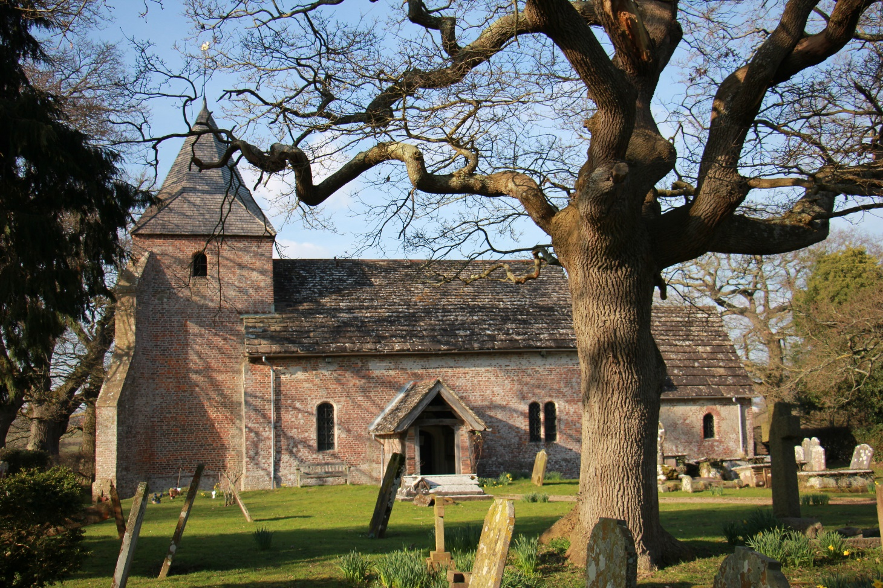
PERSON SPECIFICATION
Criteria | Qualities | Essential | Desirable
Qualifications and training | - Qualified teacher status  - Degree  - National professional qualification for headship (NPQH) or further professional development around leadership  - Up to date safeguarding training (DSL & safer recruitment)
Experience | - Successful leadership and management experience in a school  - Successful teaching experience within the EYFS/Primary age range  - Involvement in school self-evaluation and school improvement planning  - Demonstrable experience of successful line management and staff development  - Participation in school peer-review / school-to-school collaborative arrangements
Skills and Knowledge | - Ability to articulate a clear vision and inspire others  - Ability to develop positive learning cultures, for both pupils and staff, with a deep understanding of what high quality professional and personal development looks like  - Ability to build high functioning, collaborative teams and develop effective working relationships  - Strong data analysis skills  - Understanding of high-quality teaching, informed by evidence, and the ability to model this for others  - Understanding of school finances and financial management  - Effective communication and interpersonal skills
Personal Qualities | - Commitment to ethical leadership and to uphold the 7 principles of public life (the Nolan principles) at all times  - A commitment to getting the best outcomes for all pupils and promoting the Christian ethos and values of the school  - Ability to work under pressure and prioritise effectively  - Commitment to maintaining confidentiality at all times  - Commitment to safeguarding and equality, ensuring that personal beliefs are not expressed in ways that exploit the position  - Enthusiasm for climate friendly practices and a drive to work towards a carbon-neutral school

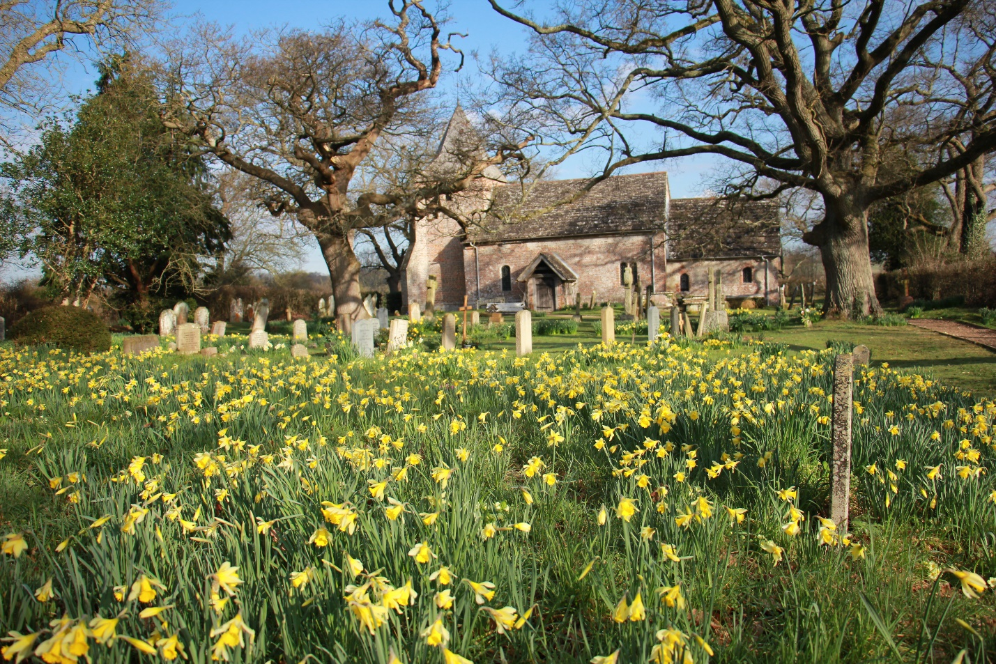

Ofsted Quotation

‘The nurturing environment permeates the school. Pupils are kind to each other and relationships between adults and pupils are warm. Parents appreciate the positivity and friendliness of staff, with one parent summarising, ‘The most special aspect of Twineham school is the sense of community.’’
17 November 2022

Twineham, West Sussex - Our locality

How to find us:

Twineham C of E School, Church Lane, Twineham, Haywards Heath, West Sussex, RH17 5NR
Approaching from the A23, leave at the junction with the A2300 (where there is a large petrol station) and head westwards towards Twineham. Turn left at the T-junction, then first right (signed to Church and school).

Twineham itself is a small scattered rural community, with its church and school at the heart of farming land in a beautiful location. A significant percentage of our children come from outside our catchment area. Henfield to the West and Burgess Hill to the East, are 10 to 15 minutes away by car. The Sussex Prairie Garden is nearby.

The area around Twineham is rich in vibrant, attractive and friendly towns and villages. Culture abounds in all its forms, and there are many beautiful country walks, stately homes and all kinds of attractions including:

• The city of Brighton & Hove
• The ancient town of Lewes
• The University of Sussex
• The protected South Downs
• Arundel and its castle
• The opera at Glyndebourne
• The ferry at Newhaven
• Gatwick Airport
...and much more.
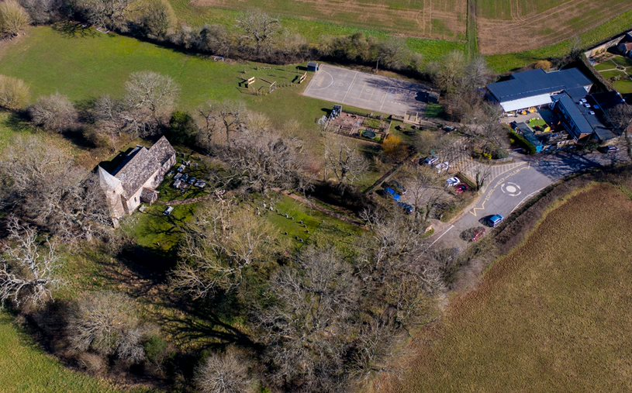

Twineham CofE School: Information for Applicants

The application form and supporting statement should be submitted to Recruitment Services Administration (RSA) at
HRSchoolAdverts@westsussex.gov.uk
quoting reference 16403 by
12 noon on Thursday 27 April 2023
The supporting statement will be no longer than two sides of A4, and should give evidence of how you meet the personal specification and provide evidence of impact from your current or past experience by referring to the Head Teachers Standards where appropriate.
Interviews will be held on
16 and 17 May 2023
We require three references, including one from the Church, which will be sought for shortlisted candidates prior to the interview date. All applications will be treated in the strictest confidence.
Visits to the school are warmly welcomed. To arrange an informal visit to the school, please contact Siobhan Reynolds (Office) or Mary Candy (Bursar) on 01444 881207 or email office@twineham.w-sussex.sch.uk.
Terms of Appointment
Twineham CofE School is committed to safeguarding and promoting the welfare of children. We expect all staff, governors, volunteers and visitors to share this commitment. The post is subject to enhanced disclosure from the Disclosure and Barring Service (DBS), satisfactory references, proof of qualifications and medical declaration and proof of entitlement to work in the UK. It will be offered subject to ratification by the Full Board of Governors.
Twineham CofE School,
Church Lane, Twineham, Haywards Heath, West Sussex, RH17 5NR
Telephone: 01444 881207

www.twineham.w-sussex.sch.uk

