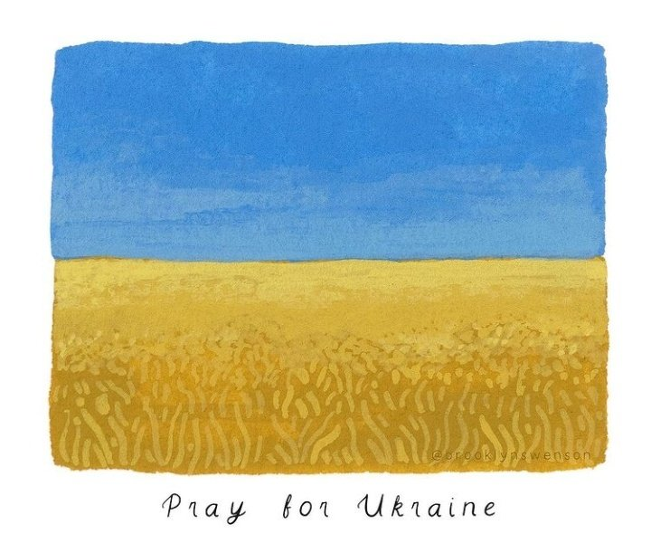
EXTRA: Prayers for Ukraine
There is an accompanying PowerPoint for this assembly
Age range: Primary
Theme: This is an extra collective worship, written in response to the crisis in Ukraine, and to give voice to some of the concerns, fears and hopes that we all share as we watch the news unfolding daily. You know your school communities best, so please use or adapt what we have written to suit the ages and sensitivities of the children in your care. There are lots of other resources to support you during the coming days on our website: Latest Collective Worship Resources | Diocese of Guildford (cofeguildford.org.uk)
Resources:
- The PowerPoint slides are numbered with a point in the script so you can find your way, and the parts in bold show you where to click on to activate the next slide or animation.
- There are two versions of prayers to choose from
Gathering:
- Slide 1: Use these new gathering words for this term, or your usual greeting if you prefer.
Engaging:
- Slide 2: We’re all seeing a lot about the situation in Ukraine and Russia on the news in recent days, and like so many others across the world, we feel helpless, sad and concerned.
- We’re going to use our time today to pray about these things and bring them before God.
- Slide 3: It’s hard for us to see what’s going on, and feel that we can do so little to change things.
- However, we must remember that there are people in Russia who don’t agree with what’s happening in Ukraine, ordinary people like us, and Christians (and people of other faiths as well) in Russia who will be praying for peace and justice – just as there are Christians in the Ukraine praying the same.
- Slide 4: There are also people all over the world who are standing with the people of Ukraine: many cities have lit up their famous landmarks with the blue and yellow colours of the Ukrainian flag to show their support.
I wonder what we might do to show our concern today, and in the days that lie ahead?.... [you might want to create time to talk about this here, or at another point]
- Slide 5: A long time ago, another group of people were living in hard times.
God’s people, the Israelites, were being treated cruelly by the Egyptians. The people cried out to God for help.
Listen to these words from Exodus chapter 2 verse 24:
“God heard their cries, and he remembered the agreement he had made with Abraham, Isaac and Jacob. God saw the troubles of the people of Israel, and he was concerned about them.”
I wonder if you noticed two short phrases in particular?
God heard…. God saw…. God heard the cries of his people and saw what was going on.
- Slide 6: Christians believe that God still hears and God still sees all that’s going on in our world today. This weekend, churches all over the world will have been filled with people bringing their concerns about what they have been hearing and seeing to God, and we are going to do the same now.
- Slide 7: But sometimes it’s hard to know quite what to say, or how to say it.
Christians will often turn to the words of King David’s Psalms to help them – and we’re going to do the same to help us. Listen to these words [each phrase animates separately. Read them out and if necessary, explain any unfamiliar words to children]
King David prayed words like these often: he lived through times of war and times of peace – and he knew from his own experience how God was with him, that God heard, God saw and God answered.
As we think about the situations we see – and the people who are caught up in the middle of them all – these words written by King David give us permission to express our concerns, and our desires for justice and peace, bringing them before God who sees and hears, and answers.
Responding (words for worship):
- Slide 8: We’re going to use some of those words to help us to pray now; you can join me if you’d like to, or if praying is not something that you’re comfortable with, then hold your own thoughts in your head and heart.
The challenge of praying this prayer is that we may not always know that our prayers have been answered – but we can be sure that God hears what we pray. So, let’s pray with confidence and compassion….
When I say the words ‘We call to you in our distress’, you can join me with ‘We trust you to answer us.’
Prayer:
Slide 9: God who hears and sees,
We bring to you the people of Ukraine
May you comfort them and bring peace to their homes and to their hearts
‘We call to you in our distress’,
‘We trust you to answer us.’

Slide 10: We pray for Christians in Ukraine and Russia
May you use their hands to bring healing and hope
‘We call to you in our distress’,
‘We trust you to answer us.’

Slide 11: We pray for our world’s leaders
Guide how they react to all that is happening.
May peace and hope triumph over fear and hate
‘We call to you in our distress’,
‘We trust you to answer us.’

Slide 12: In a few moments of quiet, I invite you to bring your own worries, sadness and hopes to God now…..
‘We call to you in our distress’,
‘We trust you to answer us.’

Slide 13:
God of peace and God of love
‘We call to you in our distress’,
‘We trust you to answer us.’
Amen

Alternative prayer, as you light a candle:
We light this candle for peace…
May its light scatter the darkness;
may its flame be a symbol of hope;
may its burning be a sign of faith joining with many other lights around your world, for peace.
Amen
Sending: Slide 14 & 15 (2 versions)
Leader: As we leave this place & time and go into the day ahead…
All: May we live peacefully with each other. / May you grant your peace, God.

